

FACULTY OF ENGINEERING AND THE BUILT ENVIRONMENT

DEPARTMENT OF ELECTRICAL ENGINEERING TECHNOLOGY

Ramolatela Lebaea

221064591

NETWORKS 2B

Understanding Network Connectivity

October 2023

Dr. A. Alonge

Table of Contents

1. INTRODUCTION 2
   1. Objectives 2
2. APPARATUS 2
3. OUTPUT RESULTS AND ANALYSIS OF RESULTS 8
4. CONCLUSION 12

#### Figure 1: Network Diagram 5

#### Figure 2: PC1 Details 5

#### Figure 3: PC2 Details 6

#### Figure 4: PC3 Details 6

#### Figure 5: PC4 Details 7

#### Figure 6: PC5 Details 7

#### Figure 7: PC2 PING Output 8

#### Figure 8: Wireshark Captured Output 8

#### Figure 9: PC3 PING Output 9

#### Figure 10: Wireshark Captured Output 9

#### Figure 11: PC4 PING Output 10

#### Figure 12: Wireshark Captured Output 10

#### Figure 13: PC5 PING Output 11

#### Figure 14: Wireshark Captured Output 11

# INTRODUCTION

## Objectives

#### To be familiar with the eNSP and Wireshark software by connecting devices like desktops, switches, and a hub on eNSP and capture the results on Wireshark

#### To have a brief understanding of network traffic

# APPARATUS

#### 5× Desktop computers

#### 2× Switches

#### 1× HUB

#### Copper wires

**Module Name:** NETWORKS 2B **Module Code:** NETELB2 **Programme:** BEngTech **Points Allocated:** 30 points **August 2023**

**LABORATORY 0-3: Understanding Network Connectivity**

**Resource(s):** Huawei eNSP simulation software.

### Objectives

1. Set up and navigate the eNSP simulator application.
2. Demonstrate basic networking skills using eNSP.

### PROCEDURE

1. Create the following network diagram. This should be done in the specified topology. Make sure that clocking is enabled on both routers. Remember to save your work regularly.

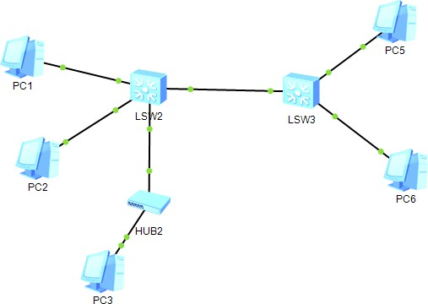

1. The numbering of all the PCs and networking devices must match the diagram above (excluding port numbers) (if changed must make sense).
2. From your classroom study of IP addresses, subnet masks and default gateways, apply this gained knowledge to step 4.
3. For each PC configure IP addresses, subnet masks and default gateways by clicking on each PC respectively. Do the same for the routers. **The IP addresses must all start will a number that is greater than 100!** Use your own numbers – as long as the devices can communicate with each other.
4. Create and send a packet between any two PC’s. Make sure that there is a successful connection between all PC’s by using the ICMP ping command. For example, in the diagram above, PC0 should send a packet successfully to PC1, PC2, PC3 and PC4. The same for PC3 and PC4 – thus the network should be configured correctly so that any source and destination PC combination will work. Use Wireshark to capture the network traffic for all instances of ICMP ping for each PC. Present the table below in your report by populating it with your own information about the IP addresses used in this design.

|  |  |
| --- | --- |
|  | **IP Address** |
| **Network Address** | 192.168.5.0 |
| **Subnet Mask** | 255.255.255.0 |
| **PC1** | 192.168.5.2 |
| **PC2** | 192.168.5.3 |
| **PC3** | 192.168.5.4 |
| **PC4** | 192.168.5.5 |
| **PC5** | 192.168.5.6 |

1. Take pictorial evidences of the results obtained in 4 for use in your report and provide sufficient explanation for those results in your report.

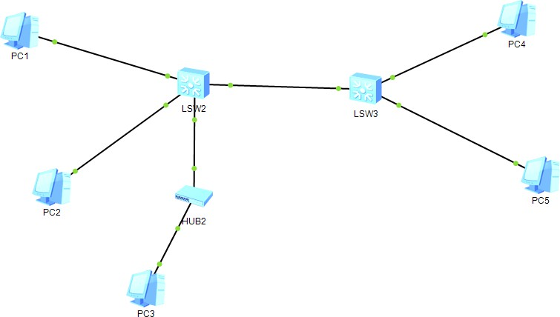

*Figure 1: Network Diagram*

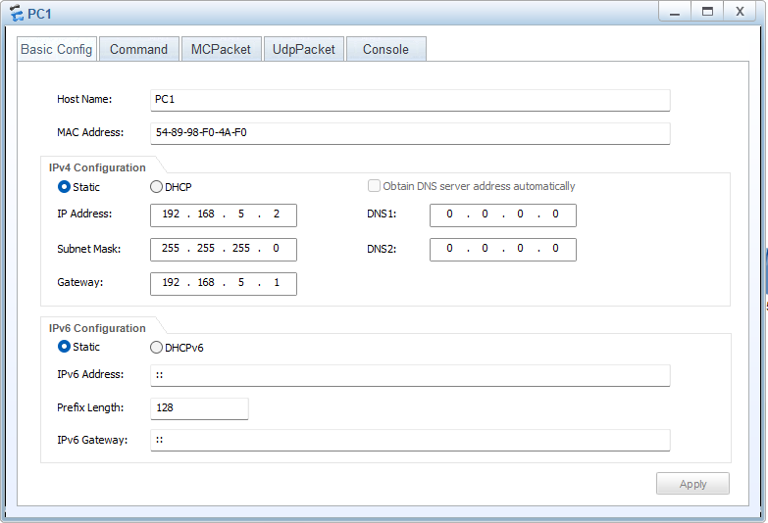

*Figure 2: PC1 Details*

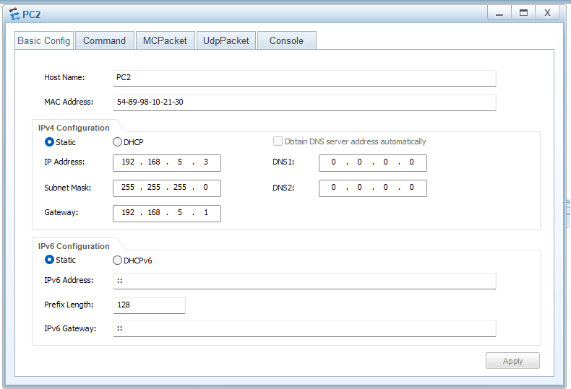

*Figure 3: PC2 Details*

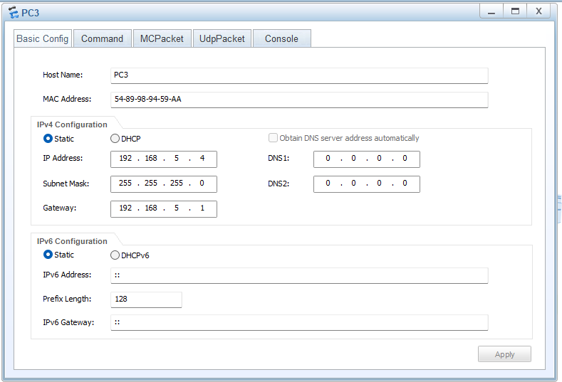

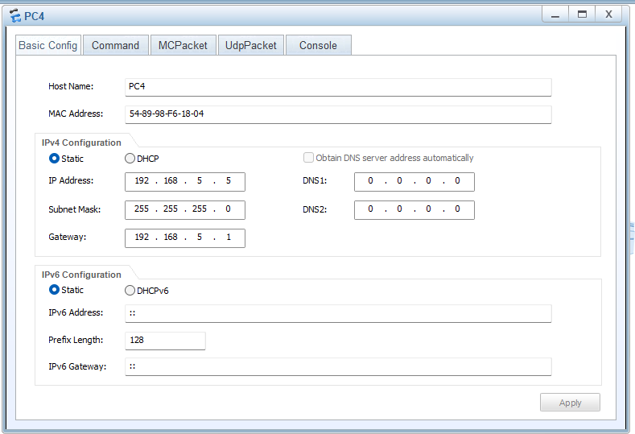

*Figure 5: PC4 Details*

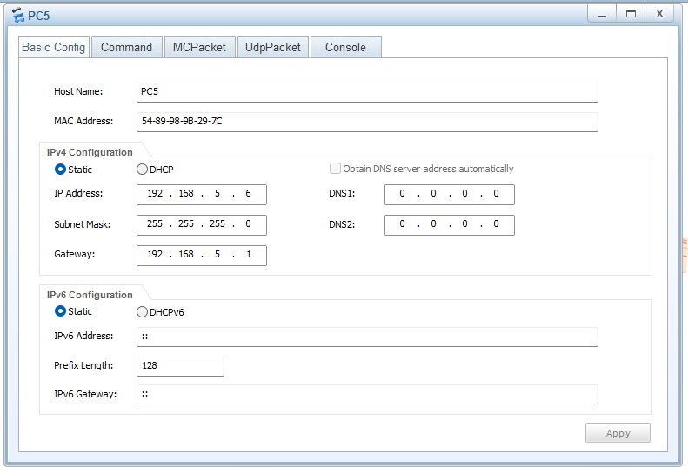

# OUTPUT RESULTS AND ANALYSIS OF RESULTS

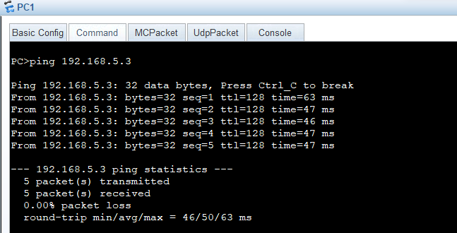

*Figure 7: PC2 PING Output*

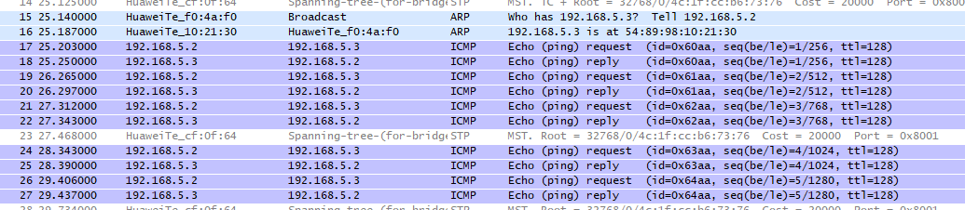

*Figure 8: Wireshark Captured Output*

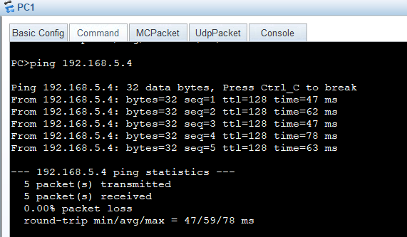

*Figure 9: PC3 PING Output*

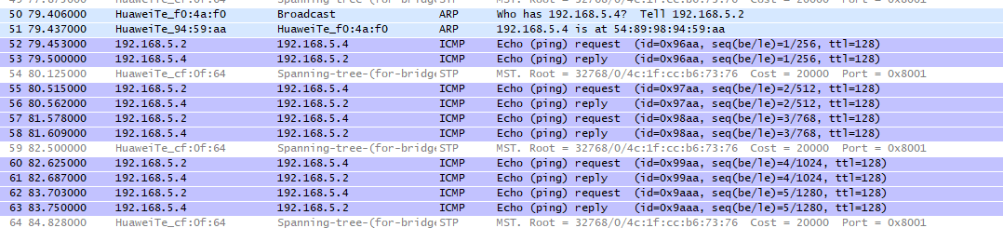

*Figure 10: Wireshark Captured Output*

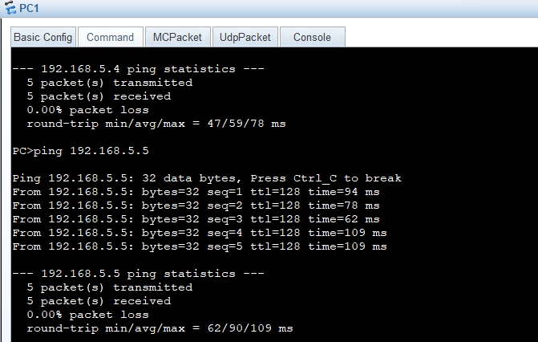

*Figure 11: PC4 PING Output*

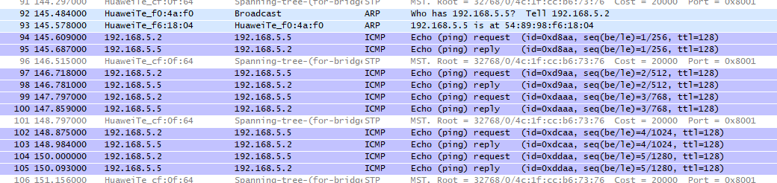

*Figure 12: Wireshark Captured Output*

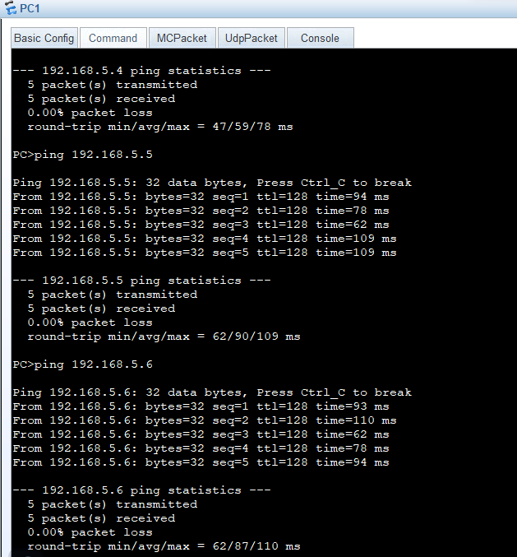

*Figure 13: PC5 PING Output*

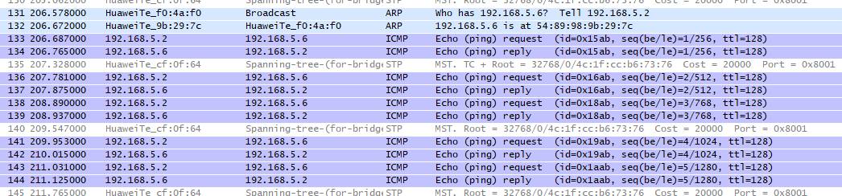

*Figure 14: Wireshark Captured Output*

#### As shown in **Figures: 8, 10, 12, and 14**, I captured the output of PC1 on the Wireshark software. Thus, I pinged PC2, PC3, PC4, and PC5 using the command prompt of PC1, as I was capturing the output of PC1. Upon checking the output of PC1 on Wireshark, it was found that PC1 was connected to all the linked PCs. Hence, PC2 is connected with PC3, PC4, PC5, and so forth.

# CONCLUSION

#### In this lab about "Understanding Network Connectivity," I learned how to use the eNSP software and different devices. Wireshark showed how devices talk in the network. This helped me know how things connect and how data moves. I enjoyed this lab because now I can understand how devices connect through networks. So I have a clear understanding of how we can check if devices are connected, like the ones at Studio A.